Press release | 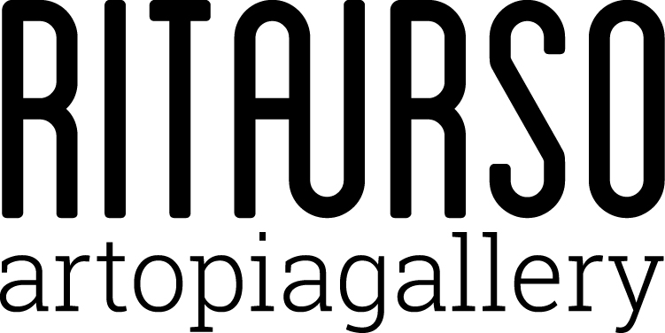

Davide Allieri
duet

RITA URSO Artopia Gallery
Via Lazzaro Papi 2, Milan

Opening February 2, 2017 at 7 pm

February 2 | March 15, 2017

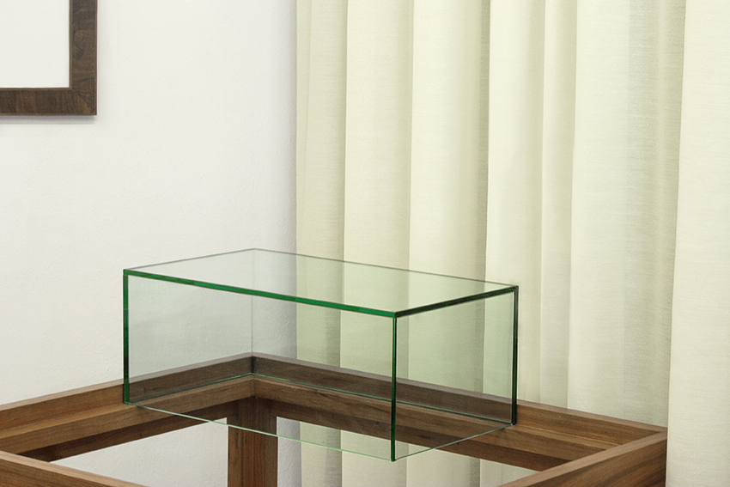
Davide Allieri, Insieme, 2016, fotografia a colori, 20 x 30 cm

RITAURSO Artopiagallery is pleased to present the first solo exhibition of Davide Allieri (Bergamo, 1982) in Milan. Influenced by classical culture and contemporary philosophers, from Deleuze to Didi-Huberman, Davide Allieri investigates emptiness, lack, negation, anti-narration, fragments, history, marks, the negated image. He does this through the use of numerous media: sculptures, installation, pastel, graphite, photography, drawing.
The exhibition titled duet, curated by Daniele Perra, has been entirely conceived around the notion of the double, intended, on the one hand, as a replica, a reproduction, and a track, while on the other as opposition between two elements: emptiness and fullness, positive and negative. The artist asks complex questions that embrace the theme of the relationship between life and death and the nature of the double, exhibiting in the gallery spaces a vast body of work composed of a mirroring pair of display cases emptied of all objects, a photo diptych that, at a distance, resembles an ancient painting; a pair of two large pastels on canvas; a photo of two ancient statues; an identical pair of slender parallelepipeds; a series of modules, almost identical replicas, seemingly rough but enriched inside. A copy, states Davide Allieri, “is never identical to the original. Though perfect, it will always have that minimum of margin that makes it unique.”

After graduating from the Brera Fine Arts Academy in Milan, Davide Allieri (1982) moved to London for some time. Between 2014 and 2015 he was the assistant of Marcello Maloberti also at Naba (Nuova Accademia Belle Arti, Milan) in the Visual Arts course. Selected group exhibitions include: Résonance, Placentia Arte, Piacenza; 1,068 cubic meters, curated by Wunderkammer, MAG, Museo Alto Garda, Trento; Desiderio, curated by Arianna Rosica, Damiano Gullì, and Barbara Meneghel, L’Arca, Teramo; AWAY, curated by Barbara Meneghel, Monza, Milan; Human Behaviour, MARS, Milan; MyBodyIsYourBody, (CACT|MACT), Centro Arte Contemporanea Ticino, Bellinzona; Ogni cosa a suo tempo, curated by Stefano Raimondi and Mauro Zanchi, BACO, Bergamo; Tutta colpa dell’amore, curated by Sara Fontana, ALT, Bergamo. He has also taken part in various residencies including: Atrii, Fabbrica del Vapore, Milan; Archeologia del Contemporaneo e del Confine, Wunderkammer Trento; Studio, ViaFarini in Residence, Milan; Licht und Luft, CARS, Omegna. duet, at RITA URSO Artopiagallery in Milan, is his first solo show in Milan.

A journalist and curator, Daniele Perra is the head of ARTRIBUNE in Milan and professor of Contemporary Art and Visual Culture at IED, fashion. He was the co-founder and editor of unFLOP paper. He collaborates with Italian and international newspapers and magazines including pagina99, SOLAR, GQ Italia, ArtReview, MOUSSE, Useless Magazine. He has written essays for catalogues and has curated exhibitions such as: Etna rêverie (2016) first artist residence at the foothills of the Volcano; Shahryar Nashat with the Centro Pecci, Cantieri Culturali ex-Macelli, Prato (2003); Project Room. A show without works / Una mostra senza opere (Spazio Lima, Milan 2005), later hosted at La Box Bourges, Ecole Nationale Supérieure d’Art de Bourges; Hans Schabus and the Very Pleasure (Laboratori del Teatro alla Scala, Milan, 2006), Trallalero, project by Luca Vitone (Fossati Esterni del Castello Sforzesco, Milan, 2007); Site_Specific (Crystal Garden), project by Flavio Favelli (La Carrozzeria, Milan, 2008); PLAY IT, a performance event at the Tennis Club Parioli, Rome (2011). In 2007, he published the volume Impatto Digitale. Dall’immagine elaborata all’immagine partecipata: il computer nell’arte contemporanea with Baskerville, Bologna. He has also been on the selection committees for: FURLA Art Award (2007) and The Sovereign European Art Prize. He has taught at NABA, HFFA, and SPD in Milan. He was editor-in-chief of tema celeste (1999–2007) and KULT (2007–2010), and between 2000 and 2006 he collaborated with Il Sole24ORE (Sunday issue) and the Saturno culture insert for Il Fatto Quotidiano.

RITAURSO | via lazzaro papi 2 | 20135 milan | t +39 02 5460582 | artopiagallery.net | info@artopiagallery.net

