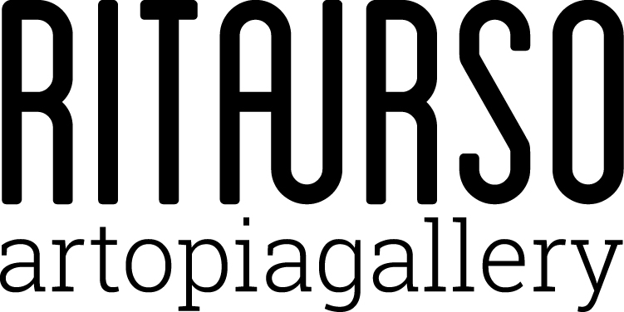

Tuesday 25th October 2016 at 7 pm RITA URSO opens the exhibition

Antonio Catelani

REDOX

text by Daria Filardo

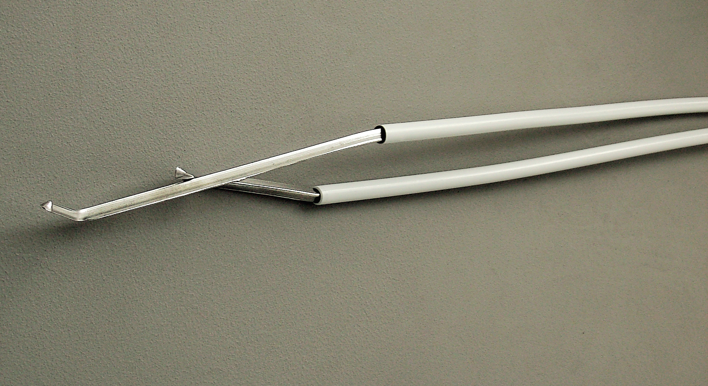

Antonio Catelani, Stannum, 2011 (detail), synthetic pipeline, tin bars

RITAURSO artopiagallery is glad to present the first gallery solo show by Antonio Catelani (Florence, 1962), internationally active artist, belonging to the generation of Italian artists who started their career in the mid ‘80s.
Catelani exhibits on this occasion a series of paintings realised specifically for the show, which title is Abwesenheiten in Preuβisch Blau (Absences in Prussian Blue). Prussian blue is a highly unstable colour, destined to chromatic change and oxidation. The chemical compound, named ferric ferrocyanide, gives life to a very particular blue, also known as Eisenblau (iron blue) which, under the action of sunlight and in contact with the prepared canvas, changes colour, assuming a shimmering look, and finally comes back to its irony nature, literally rusting. These paintings are the most recent outcome of a wider cycle, started in Berlin (where the artist lives and works since 2007), where the monochrome is reconfigured on the precarious border between image and objectification of the pictorial surface.
On the upper floor of the gallery will also be presented a new installation composed of a group of sculptures characterized by a very reduced physicalness, which title is Stannum. Made out of metal (tin bars) and synthetic pipeline, these works created in 2011 are collected and exposed together for the first time on this occasion. Stannum is the Latin name of tin: a ductile metal, apt to alloy and tie, which is also a very good electric conductor. The sculpture that bears the name of this metal shows its different peculiarities, not even concealing its innate weakness.
Daria Filardo writes: “In the recent works by Antonio Catelani the thought on painting categories is focused on duration, on attention, on the minimal gesture that shifts the idea of finiteness of the work and pushes it towards its transformation point. Everything is really unstable.
Sculpture and painting. Color and shape. The edge of the painting and the gesture which is impressed on it. The shape of sculpture that collapses and falls leaving traces of the movement produced by the nature of the material and by gravity force.
The sculptures presented in the exhibition are threadlike, malleable, broken shapes appearing like waste or roots that move looking for balance. The paintings are canvases where Prussian blue will not always be blue but, becoming oxidized, will change its nature. In every work by Catelani minimal references live together with organic and processual nature, and suggest a strong attitude to concentration on the matter and on its symbolic and formal relationships.
Everything is really variable, everything is changing, everything look fragile in its nature and it is from this fragility that spring out a movement, another shape, a gaze which can not stop at the recorded figure because it will become, with time, another work.”

Antonio Catelani (1962, Florence) lives and works in Berlin. He studied at Florence Academy of Fine Arts and Akademie Schloss Solitude in Stuttgart.
His works have been exhibited in various international institutions, among which XLIII Biennale di Venezia; Berlinische Galerie/Martin-Gropius-Bau, Berlin; Künstlerhaus Villa Romana, Florence; MUMOK, Wien; Quadriennale d’Arte di Roma, Rome; Galleria Nazionale d’Arte Moderna, Rome; PAC - Padiglione d’Arte Contemporanea, Milan; Museo Marino Marini, Florence; MoCA, Shanghai; Museo Pecci, Prato; Polo Museale - Galleria dell’Accademia, Florence.

RITAURSO | via lazzaro papi 2 | 20135 milano | t +39 02 5460582 | artopiagallery.net

