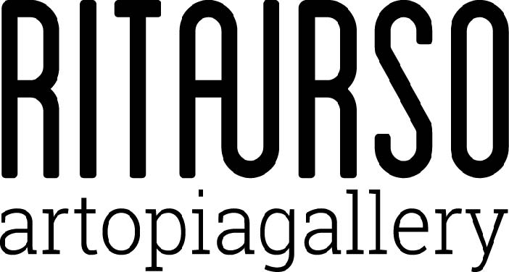

Opening Wednesday 25 November 2015 at 19.00 RITA URSO
by Carlo Guaita curated by Saretto Cincinelli

Urania

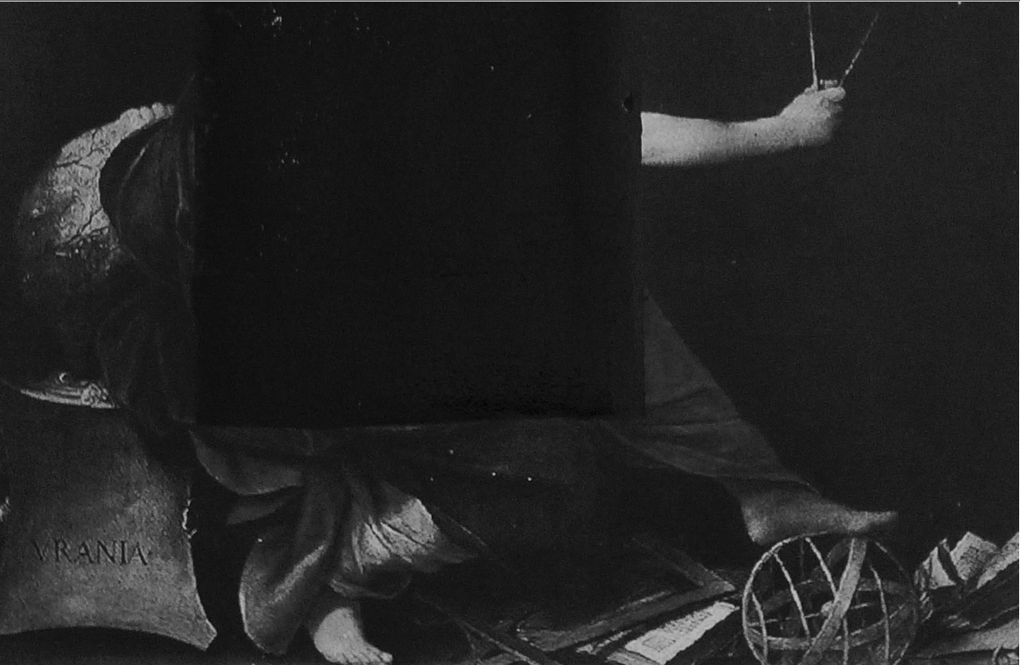

Rita Urso is proud to present Urania, a solo show by Carlo Guaita and curated by Saretto Cincinelli. On display will be paintings and sculptures made between 2010 and 2015, including “Urania”, a collage from the series Prosopopee, which provides the show’s title.
The artist’s work tends to refer knowingly back to itself in a digressive manner, in sort of continuing encyclopedia of themes and figures of modernity; its self-referentiality is repeatedly both affirmed and contradicted by an incessant manipulation that is constructive and deconstructive at the same time.
Working at various levels – that of conceptual references, that of the relationships between artworks and the material used for formal elaborations – the artist effects a continuous stratification, almost an archiving and infinite cataloguing. His work, in all of its various aspects, thus presents itself as an uncertain encyclopedia, to be read at both the formal and conceptual levels, where the only form of a restitution of unity is its noticeable absence.

“Guaita - Saretto Cincinelli writes – does not encounter that which Mc Evelly defines as “the most enigmatic icon of modern art” in a conceptual process aimed at bringing painting to its definitive fulfillment; more than a faithfulness to what the monochrome was, the artist is interested in reopening the future reserve that the latter contains, as that which destines it to resist saturation and pushes it constantly up against its limits. Coming to its presence, by means of a sort of flipping over of the bottom of the painting onto its surface, Guaita’s monochrome realizes a presentation that is not subject to any representative logic, an appearance unburdened by any sort of subordination that, in its exclusion of every behind, lays foundations: the infinite of a new beginning; something more than the contrary of a fulfillment, different from the restoration of an origin: a space of extra-representational waiting, in which the too visible of form and the invisible of foundations show their surfaces of immanence, their common visibility that mines and scours, going beyond all of their reciprocal contrasts. For Guaita, art doesn’t consist in giving form to material but in taking, by means of an erasure and transfiguration of form, the viewed and the visible to their extreme edges, to the limit of their virtuality… Guaita’s extra-representational presentation appears, therefore, as the contrary of a totalization.

