Press Release

Johannes Wald
mostra personale

RITA URSO Artopia Gallery
Via Lazzaro Papi 2, Milan

Opening 28 November 2017 7 pm

28 November 2017 | 26 January 2018

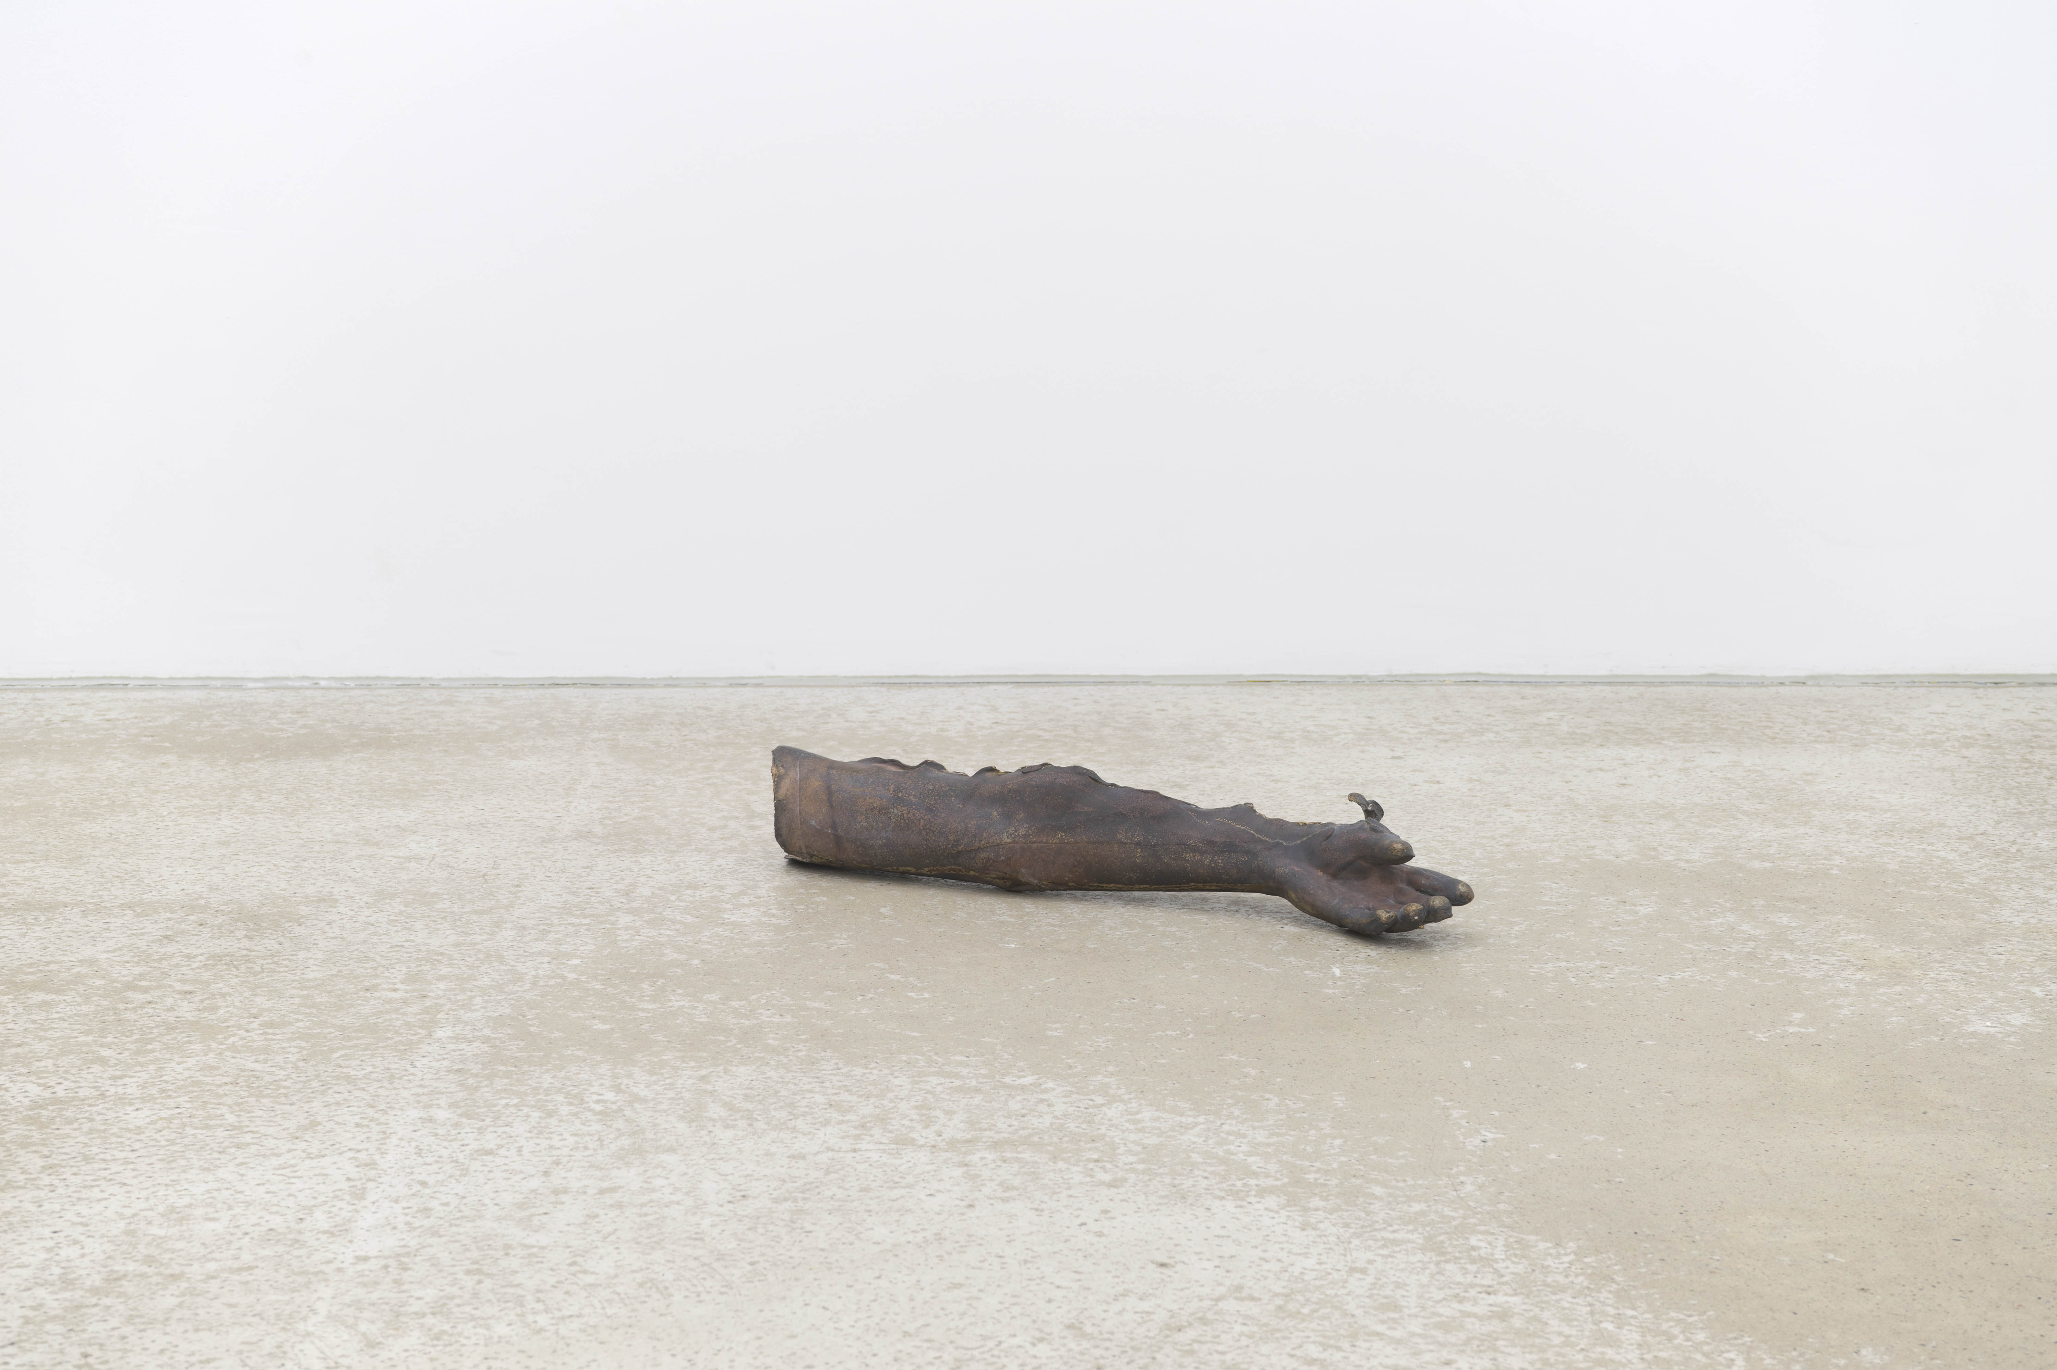

Johannes Wald, Grace is a Volatile Matter | 2016 bronze, 17x80x17 cm

RITAURSO Artopiagallery is pleased to present the first solo show in Italy by Johannes Wald (Sindelfingen, Germany, 1980).
Johannes Wald’s art belongs to the world of sculpture, set in the moment which precedes the work taking form, in an almost perennial state of “becoming”. Indeed it is not even possible to define him as a sculptur except in the sense of the German term bildhauer, “one who gives form to images”. His works are never complete but live in variations and on continual reformulations of the question of the indissolubility of form, matter and content. Johannes Wald uses sculpture as a language in order to reveal – through vacuum, ellipses, and omissions – the process and the transmission of the conditions of existence of objects, inside a genealogy of aesthetic canons and a collective memory that identify them.

The idea that matter has an inherent form, albeit one that is not directly codifiable visually, is at the heart of the show thought by the artist for this occasion. Opting for a structure that is open to interpretations, in this case by presenting four different variations on a single theme, Johannes Wald models matter by endowing it with some of the ephemeral features of a living creature, such as breath, warmth, movement, and speech. Thus form does not emerge as the descriptive canon of the image but as the organic presence of the matter, moving the attention from the potential object to its substance. By modeling matter inversely the artist reverses the sculptural process, and overturns the rule of transformation, as in the case of the Carrara marbles that follow the human breath’s rhythm or share the living being’s body heat.

Johannes Wald was born in 1980 in Sindelfingen, Germany; he lives and works in Berlin. He studied at the Staatliche Akademie der Bildenden Künste Karlsruhe from 2002 to 2009. His solo shows include: mostra personale, RITA URSO artopiagallery, Milan; Lending Thought Body, Daniel Marzona, Berlin (2016); Whatness (with Esther Kläs), Kunsthalle Bielefeld (2015); Geste und Gefühl / attempts at forming appropriate finds, Museum Kurhaus Kleve (2014); in the shade of absence, Albertinum, Staatliche Kunstsammlungen, Dresden (2014); fig., Konrad Fischer Galerie, Düsseldorf (2012). The group shows he has participated in include: Antworten auf Calder: Mobiles in der Gegenwartskunst, Kunsthalle Wilhelmshaven (2014); KölnSkulptur#6 e #7 (2011, 2013); Vorführraum, Kunsthalle Bielefeld (2012); Private Passions, Kunsthalle Mannheim (2012); Liberalis, Städtische Galerie, Sindelfingen (2011); Fischgrätenmelkstand, Temporäre Kunsthalle Berlin (2010); call it what you like, Silkeborg Art Center, Denmark (2008); Regionale8, Kunsthalle, Basel (2007); See History, Kunsthalle zu Kiel (2005).

Giulia Bortoluzzi (1987) lives and works in Milano. Graduated in Contemporary philosophy and aesthetic, she writes of art and design and works in collaboration with galleries, foundations and no profit exhibitions spaces in France and in Italy. She worked for the Cartier Foundation for Contemporary Art in Paris and she took part to the curatorial project of the solo show by Liam Gillick From 199C to 199D (2014) at MAGASIN - Centre National d'Art Contemporain, Grenoble. She is a regular editor for L'Officiel Italia and Hommes, Juliet and Icon Design (Mondadori).

RITAURSO | via lazzaro papi 2 | 20135 milan | t +39 02 5460582 | artopiagallery.net | info@artopiagallery.net

Works on show:

First floor

Grace is a volatile matter, 2016, bronze, 70x12x16 cm

Untitled, 2017, embossed paper, 47,5x36,5 cm

Cold veins/warm light, 2017, marble plate, HD projection, 140x93x4 cm

Stone with no form (La nebbia malinconica di Carrara), 2017, one hand full of marble dust, variable dimensions

Second Floor

Giving body to the stone (I sognatori), 2017, marble (heated up to 36,7°C by heating cables and temperature controllers), variable dimensions

