Press Release | 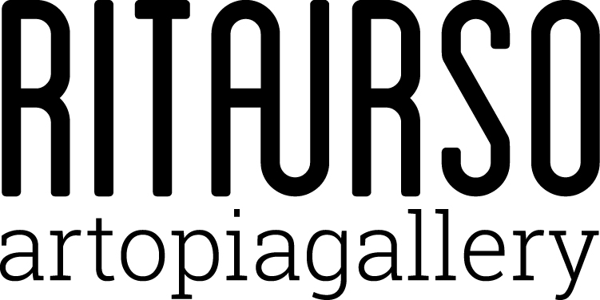

UNDER OVER THROUGH

Emiliano Aversa / Jesse Benson / Adam Henry
Beatriz Olabarrieta / Naoki Sutter-Shudo / Priscilla Tea

curated by Domenico de Chirico

RITA URSO Artopia Gallery
Via Lazzaro Papi 2, Milan

Opening 27 February 2018 at 7 pm

27 February 2018 | 27 April 2018

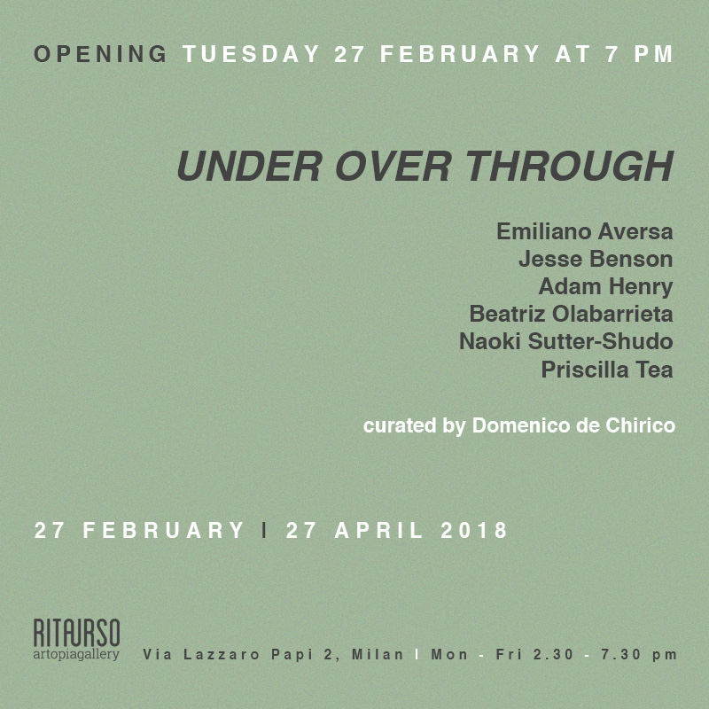

RITAURSO artopiagallery is pleased to present UNDER OVER THROUGH, the collective show with works by Emiliano Aversa, Jesse Benson, Adam Henry, Beatriz Olabarrieta, Naoki Sutter-Shudo, and Priscilla Tea, curated by Domenico de Chirico.
The show sets out to reflect on the concept of perception understood not as the result of a series of causal sensations but rather as that group of perceptual actions that go beyond the organic level. The focus of UNDER OVER THROUGH is not the material texture of the works in a scientific sense or even their aura, but that undefined space that is work itself seen as the emanating field that opens up a series of dynamic possibilities. It is above all an exploration of the development of sense, which, continuously enriching itself in the process of perception, takes on a perspective that weaves itself under, over, and through. This sense and its continuous wandering actually have a single point of emanation, despite inhabiting a more extended mobile state. The movement is at times sinuous and silent, and at others volatile or in a phase of preparation, like an implosion that becomes visible to the external gaze. Thus every work in the show answers to a different dynamic level, some have already been traversed, while others are ready to be, obsessively and continuously renewing a cycle in which the beginning and end points are unrecognizable.

RITAURSO | via lazzaro papi 2 | 20135 milano | t +39 02 5460582 | artopiagallery.net | info@artopiagallery.net

Emiliano Aversa (1984) lives and works in Milan. Graduated in Philosophy and in Direction and Performing Video at Istituto Superiore di Design. His first solo show Movement as Parresia took place in 2017 at SOYUZ project space, Pescara. Selected group shows: UNDER OVER THROUGH, RITA URSO artopiagallery, Milan (2018); YES!, Cinnnamon, Rotterdam (2018); X.perience an exhibition in Space, In de Ruimte, Ghent (2017).

Jesse Benson (1978, Orange, CA) lives and works in Los Angeles, CA. Solo exhibitions: Miracle Grow, Michael Benevento, Los Angeles, CA (2017); Michael Benevento, Los Angeles, CA (2015); Outclassed, Campbell Hall Gallery, Los Angeles, CA (2013); Jesse Benson at Venice 6114, Venice 6114, Los Angeles, CA (2013); Magic Johnson Smile, Elephant, Los Angeles, CA (2012); Hedge Your Bet, Mandarin Gallery, Los Angeles, CA (2004). Recent group shows: UNDER OVER THROUGH, RITA URSO artopiagallery, Milan (2018); Really?, curated by Beth Rudin DeWoody, Wilding Cran Gallery, Los Angeles, CA (2017); Imagine, Brand New Gallery, Milan, IT (2016); Condensed Matter Community, curated by Evan Gruzis and Kristof Wickman, Synchrotron Radiation Center: HomeofAladdin, Stoughton,WI (2015); Villa Aurora Revisited, curated by Paul Soto, Balice Hertling, NY (2015).

Adam Henry (1974, Pueblo, CO) lives and works in Brooklyn, NY. Recent group exhibitions: UNDER OVER THROUGH, RITA URSO artopiagallery, Milan (2018); The Walk, Meessen de Clercq, Brussels, BG (2017); CMYK, Steve Turner, Los Angeles, CA (2017);Scarlet Street, Lucien Terras, New York (2016); Bewegung Auge Kopf Hand, Villa Merkel, Germany (2016). Recent solo exhibitions: As If Blue, Lundgren Gallery Palma de Mallorca, Spain (2017); As Fiction, Paris London Hong Kong Gallery, Chicago, IL (2017); The Little Apocrypha, collaboration with Emily Mae Smith, SALTS Birsfelden, Switzerland (2017); Handshakes and Networks, 247365, New York, NY(2016); Repetition (Repetition), Meessen DeClercq, Brussels, BG (2015). A monograph on his work from 2011-2016 was recently published by Meessen De Clercq.

Beatriz Olabarrieta (1979, Bilbao) lives and works between London and Berlin. Recent solo exhibitions: CLEVER TO FOLLOW GOAT, Antoine Levi, Paris (2017); Book! don´t tell me what to do, Parallel Oaxaca, Mexico DF (2017); DUMB BELLS, Saturdays Live, Serpentine Galleries, London (2016); Pocketful, Platform Artist in Residence, Site Gallery, Sheffield (2016); Plot Bunny, Northern Gallery for Contemporary Art, Sunderland (2015). Selected group shows: UNDER OVER THROUGH, RITA URSO artopiagallery, Milan (2018); ¿PARA QUÉ?, Parque Galeria, Mexico City (2017); Assorted Paper, The Sunday Painter, London (2017); The boys the girls and the political, Lisson Gallery, London (2015).

Naoki Sutter-Shudo (1990, Paris) lives and works in Los Angeles. Selected solo shows: Parade, Bodega, New York, NY (2017); 27 av. Stephen Pichon 75013 Paris 2007-2015, Los Angeles Contemporary Archive, Los Angeles, CA (2016);
Selected group exhibitions: UNDER OVER THROUGH, RITA URSO artopiagallery, Milan (2018); Shivers Only, La Paix, Paris, France (2017); Kill it on vacation, The Steak House Doskoi via XYZ Collective, Tokyo, Japan (2017); Instruments of the Homecoming, The Sunroom, Richmond, VA (2016); Everyday War, Ashes/Ashes, Los Angeles, CA (2016); All at Once, with Alexandra Noel, Jessica Silverman Gallery, San Francisco, CA (2016); Nothing recedes like failure, Mortadelle, Arles, France (2016). He is the cofounder of Holoholo, a publishing house based in Paris, and the exhibition space Bel Ami in Los Angeles.

Priscilla Tea (1983, Milan, Italy). Solo Exhibitions: Screen Trauma, Neumeister Bar-Am, Berlin (2017); PRO- GRAM HELLO, PRINT*, ‘Hello World !’ END, Galerie Hussenot, Paris (2016); The Composing Rooms, Berlin (2014); I Made It Through The Wilderness, Preteen Gallery, Mexico City (2013); Gloria Maria Gallery, Milan (2012). Group exhibitions: UNDER OVER THROUGH, RITA URSO artopiagallery, Milan (2018); Super Superstudio, radical art and architecture, PAC, Milan (2015); Three Rooms, Galerie Gabriel Rolt, Amsterdam (2015); Newpressionism, Swiss Institue of Rome, Milan (2014); Thessaloniki Biennale 4, Thessaloniki (2013); Brutally morbid axe of satan, ReMap4, Preteen Gallery, Athens (2013); Guide to the Galaxy, Gloria Maria Gallery, Milan (2013); The Eternal Internet Borherhood, Mexico City (2013); BYOB, Museo Pecci, Milan (2012); BYOB, Padiglione Internet (The Island of the Net), Venice Biennale, Venice (2011).

RITAURSO | via lazzaro papi 2 | 20135 milano | t +39 02 5460582 | artopiagallery.net | info@artopiagallery.net

