Press Release | 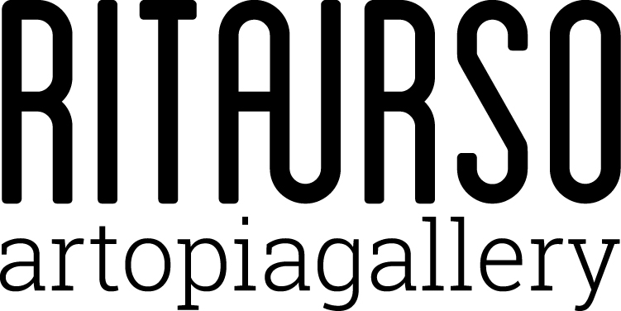

Erika Hock
performing domesticity

RITA URSO artopiagallery
Via Lazzaro Papi 2, Milan

Opening 10 October 2017 at 6:30 pm

10 October | 18 November 2017

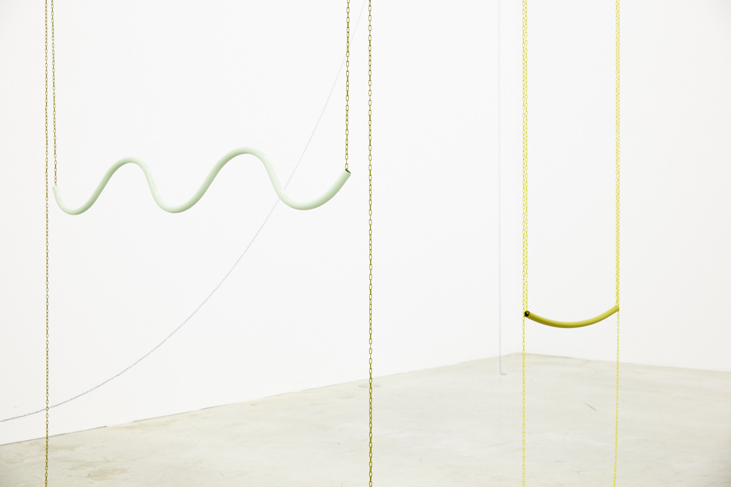

Erika Hock, Untitled | 2017 powder coated tubular steel, chain

RITAURSO is pleased to open the new exhibition season with the first solo show in Italy by Erika Hock (Dshangi - Dsher, 1981).

Erika Hock’s work explores the body and its relationship with space, in connection with architecture, design, and fashion, by creating hybrid anthropomorphic constructions of objects deprived of their functionality. These creations – best defined as quasi sculptures, objects and toys – are presented as bodies of everyday interaction, presences that we recognize as familiar and with which we have a reciprocal relationship.

In the show performing domesticity, Erika Hock explores the dialogue and the extremes in the interaction between apparently inanimate bodies of objects from the intimate spaces of our everyday lives. From this interest of hers in tubular furniture, in particular the cantilever chair, which in its lines recalls a reclining human figure, Erika Hock considers the objects not only as supports or tools for our bodies but as bodies in and of themselves. Indifferent to the notion of functionality, she works on the physicality of interiors – here destructured and subverted – to reveal its uniqueness. Thus the chairs, for instance, are not longer just chairs, but are in search of new forms, captured in the movement of exploring new possibilities of existence, inviting those who observe them to do the same. The sculptures are transformed into bodies and take on the characteristics of life; they lean against the wall and stretch out a leg to form unexpected compositions. They invite us to occupy space with flexibility and to subvert the convention of them as social tools.

The exhibition is accompanied by a publication with a text by Giulia Bortoluzzi and some pictures of the exhibited artworks.

Born in 1981 in Dshangi-Dsher, Kyrgyzstan, Erika Hock studied history at the Westfälischen Wilhelms Universität Münster and visual arts at the Kunstakademie Münster, and at the Kunstakademie Düsseldorf. From 2012 to 2013 she studied at HISK, the Higher Institute for Fine Arts, in Ghent. Recent solo shows include: Second Home, Philara Collection, Düsseldorf; The Phantom Table, Sofie Van de Velde Gallery, Antwerp; Body Body, Kunsthaus Essen; What Bananas Say, Salzburger Kunstverein, Salzburg; Elbows & Knees, COSAR HMT Gallery, Düsseldorf; The Seamstress, Her Mistress, the Mason and the Thief, Tenderpixel Gallery, London. Recent group shows include: Inhabited by Objects, CAB, Brussels; The People’s Cinema, Salzburger Kunstverein, Salzburg; Every Letter Is a Love Letter, Tallinn Art Hall, Tallinn; Un-Scene III, Wiels, Brussels; The Catwalk, Komplot, Brussels; The Unfettered Gaze, Museum Marta, Herford; Concept Store, NEST, The Hague; Fair shape of the whip, Herrman Germann Contemporary, Zurich.

RITAURSO | via lazzaro papi 2 | 20135 milano | t +39 02 5460582 | artopiagallery.net | info@artopiagallery.net

